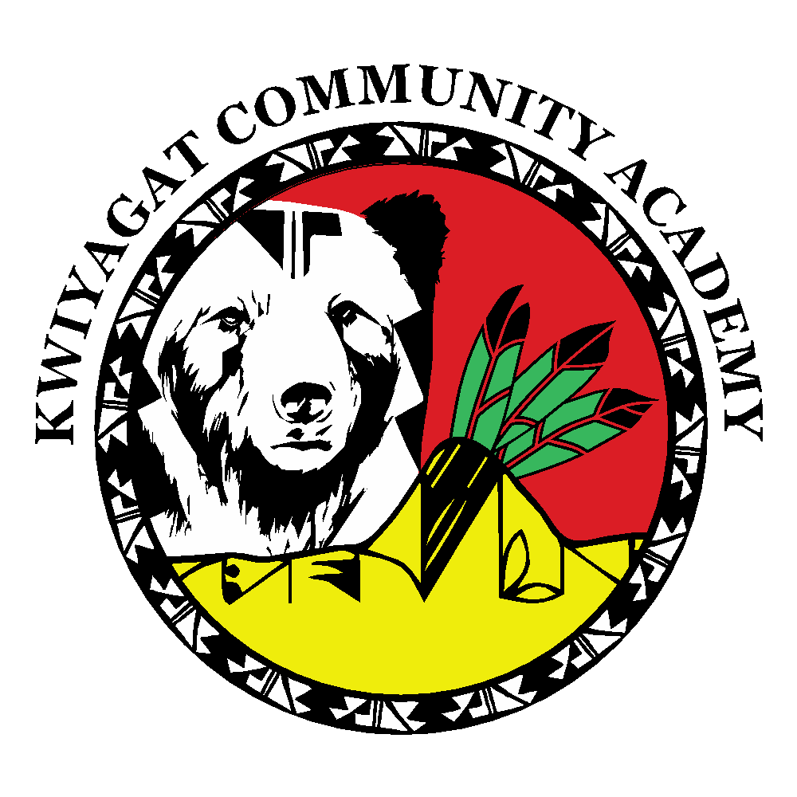

KCA Board Agenda May 12, 2022

5pm by ZOOM or in person at KCA building  <https://us02web.zoom.us/j/84005356346?pwd=Z1R3bGY0VWxaVDJ4VVhTTHVGVVIxQT09>

Call to order

Welcome

Roll Call

Approval of Agenda-Vote

Approval of the minutes for April 14th, meeting - Vote

Community addresses the Board

* Sherrell Lang – Rise Grant

Reports

* Principal report
* Accountability – Raleigh

Discussion Items

* Salary Schedules
* Recruiting Students and Staff

Action Items - Vote

* Approval of FY22 Working Budget
* Approval of FY23 Draft Budget

Executive session

To be entered into the minutes of the public meeting.

Pursuant to section 24-6-402(4) of the Colorado Revised Statutes, I move that this regular public meeting of Board of Kwiyagat Community Academy adjourn and, upon affirmative vote of

two-thirds of the members present, reconvene in executive session for the sole purpose of

Head of School evaluation as authorized by § 24-6-402(4)(f).

Re Adjourn

Adjourn