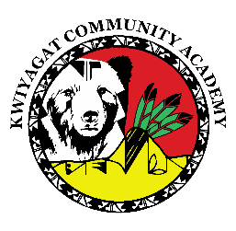
KCA Board Agenda November 13, 2025
5 pm by Zoom and in person at KCA.
https://us02web.zoom.us/j/84132747053?pwd=Y8aufACh6enJaghHeGhyIYTDX6gvi8.1
Call to order
Welcome -
Roll Call
Approval of Agenda-Vote
Approval of the minutes for October 9th, 2025 meeting- Vote
Community addresses the Board:
Lulu Buck

Reports
- Council Report – Councilor Knight
- Board Reports
- Shawn Davis – PDF consulting – Introduction
Richard Fulton/ Shawn Davis – Grants
- Principal report
Charter renewal Update
AEC update

Discussion
Cell Phone policy

Action Items:
Field Trip Policy
RIFF Policy.
Time and Effort Policy

Adjourn

