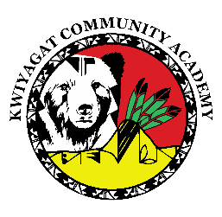
KCA Board Agenda May 14th, 2026
5 pm by Zoom and in person at KCA.
Dan Porter is inviting you to a scheduled Zoom meeting.
https://us02web.zoom.us/j/85343034977?pwd=8H5Ox4B3ZbblxkwhwxiYf7Jscg7nZP.1
Call to order
Welcome -
Roll Call
Approval of Agenda-Vote
Approval of the minutes for April 9th, 2026 meeting- Vote
Community addresses the Board:
Reports:
- Council Report – Councilwoman Knight
- Finance Committee Report
- Principal report

Discussion:
Expansion to 6th grade

Executive Session: Make a motion to enter executive session to discuss the purchase, sale, transfer, or lease of property under C.R.S. 24-6-402(4).
Action Items

Adjourn

