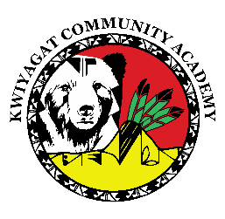
KCA Board Agenda May 15th, 2025
5pm by Zoom and in person at KCA.
https://us02web.zoom.us/j/87892354606?pwd=tvTsYKMVDdNLrxaA7k1abXtWEgyjjk.1

Call to order
Welcome -
Roll Call
Approval of Agenda-Vote
Approval of the minutes for April meeting- Vote
Community addresses the Board:

Reports
- Council Report – Councilwoman Knight
- Board Reports - CSI visit
- Grants update- Richard
- Principal report
- Staffing
- Facilities – May 20th Architect presentation to Council
- Testing
- Best Grant update
- Summer program and PD

Discussion
- June work session.

- Principal Evaluation
Action Items:

Adjourn

