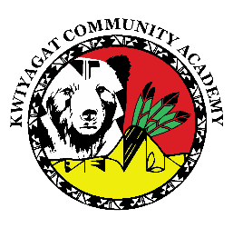  
KCA Board Agenda May 15th, 2025

5pm by Zoom and in person at KCA.

https://us02web.zoom.us/j/87892354606?pwd=tvTsYKMVDdNLrxaA7k1abXtWEgyjjk.1

Call to order

Welcome -

Roll Call

Approval of Agenda-Vote

Approval of the minutes for April meeting- Vote

Community addresses the Board:

Reports

* Council Report – Councilwoman Knight
* Board Reports - CSI visit
* Grants update- Richard
* Principal report

1. Staffing
2. Facilities – May 20th Architect presentation to Council
3. Testing
4. Best Grant update
5. Summer program and PD

Discussion

* June work session.
* Principal Evaluation

Action Items:

Adjourn