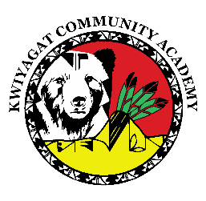
KCA Board Agenda March 12, 2026
5 pm by Zoom and in person at KCA.
https://us02web.zoom.us/j/86524995140?pwd=b14vqxbaWQ4EqJEqBiyabhRCwvaQY1.1
Call to order
Welcome -
Roll Call
Approval of Agenda-Vote
Approval of the minutes for Feb 12th, 2026 meeting- Vote
Community addresses the Board:
Reports:
- Council Report – Councilwoman Knight
- Finance Committee Report
- Principal report

Discussion:
Expansion to 6th grade
Disclosure of information to Federal Authorities
Action Items

Adjourn

