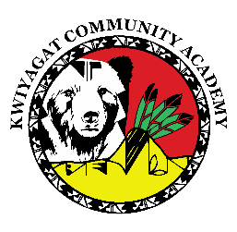
KCA Board Minutes March 12th, 2026
5 pm by Zoom and in person at KCA.
https://us02web.zoom.us/j/87959708862?pwd=pCRPR6tOp9pIwI7AeJ4FYvtZh1bAya.1
Meeting ID: 879 5970 8862
Passcode: 730777

Call to order 5pm
Welcome - Tina
Roll Call Tina – Here
Tawnie - Here
Alicia – Joined at 5:25
Ceriss – Here
Raleigh – Absent with notice
Approval of Agenda- Ceriss motions and Tawnie Seconds,
Approval of the minutes for March 12th, 2026 meeting- Ceriss Motions and Tawnie Seconds
Community addresses the Board: none
Reports:
- Council Report – Councilwoman Knight met with Jared Polis and encourage support of KCA Best grant.
- Finance Committee Report – Ceriss gave report. Finances look good. Ceriss can provide a section of Linda’s finance report to all board members.
- Principal report – Dan reported on CMAS schedule and staff training, Recruitment, Board packet included explanations of the Colorado suspension and expulsion laws for K-3 students, Dan headed to Crisis Intervention Training in April,

Discussion:
Expansion to 6th grade – Dan to contact CSI on other options besides a full classroom.

Dan to provide a Policy on school provided lunch for staff. Dan to provide minutes for staff to stay up with what board is working on.

Action Items - None

Adjourn

