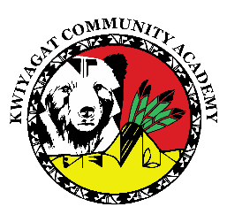  
KCA Board Agenda June 14th, 2025

2:30 pm by Zoom and in person at Little Buffalo Room, Casino.

https://us02web.zoom.us/j/83008961819?pwd=Dd0aCt1ztaNl0alerCaNfqsZoFN7E2.1

Call to order

Welcome -

Roll Call

Approval of Agenda-Vote

Approval of the minutes for, 2025 May 15th meeting- Vote

Community addresses the Board:

Reports

* Council Report – Councilman Jacket
* Board Reports
* Principal report

1. Staffing
2. Summer Program

Discussion

Betty Howe memorial

KCA RIF policy

Action Items:

Approval of “Letter of Understanding” from SJT Group for Audit.

Adjourn