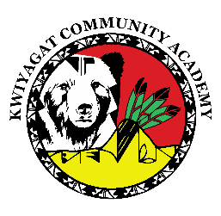
KCA Board Agenda January 15, 2026
5 pm by Zoom and in person at KCA.
https://us02web.zoom.us/j/84895013162?pwd=gUtr6TSZvgzB35Pld4BMADydOYqTMz.1
Call to order
Welcome -
Roll Call
Approval of Agenda-Vote
Approval of the minutes for Dec 11th, 2025 meeting- Vote
Community addresses the Board:
Reports:
- Ferguson and Pyatt – update on Building plans
- Council Report – Councilwoman Knight
- Finance Committee Report
- Principal report
Upcoming events
Charter renewal Update
Discussion:

Action Items:
Employee Cell Phone Policy
Approval of Revised/Amended Budget
Adjourn

