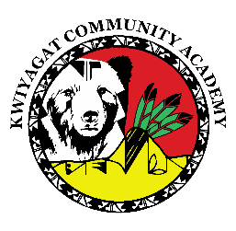
KCA Board Agenda February 12, 2026
5 pm by Zoom and in person at KCA.
https://us02web.zoom.us/j/81039089735?pwd=qzfTSpx8z8j3BibLeaIJhnxavlSaFd.1

Call to order
Welcome -
Roll Call
Approval of Agenda-Vote
Approval of the minutes for Jan 15th, 2026 meeting- Vote
Community addresses the Board:
Reports:
- Council Report – Councilwoman Knight
- Finance Committee Report
- Principal report
- Capstone project – Jen

Discussion:
TRAP agreement – this refers to teacher staying with school in exchange for help paying for education. 6
Expansion to 6th grade

Action Items

Adjourn

