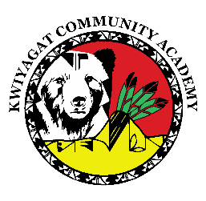
KCA Board Agenda December 11, 2025
5 pm by Zoom and in person at KCA.
https://us02web.zoom.us/j/89107948923?pwd=fbVY6Wja4btaK4us2lAbQ2do6ax9vP.1
Call to order
Welcome -
Roll Call
Approval of Agenda-Vote
Approval of the minutes for Nov 13th, 2025 meeting- Vote
Community addresses the Board:
Reports:
- Council Report – Councilwoman Knight
- Finance Committee Report
- Principal report
Upcoming events
Charter renewal Update
Discussion:
Employee Cell Phone policy
Action Items:
Field Trip Policy
Student Cell Phone Policy
Adjourn

