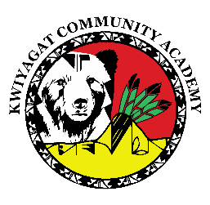
KCA Board Agenda August 13th, 2026
5pm by Zoom and in person
Dan Porter is inviting you to a scheduled Zoom meeting.
https://us02web.zoom.us/j/82269510723?pwd=VFUzJiieS4Hon9S9PgCtnEfob8IUo4.1
Call to order
Welcome -
Roll Call
Approval of Agenda-Vote
Approval of the minutes for June 19th, 2026 meeting- Vote
Community addresses the Board:
Reports:
- Council Report
- Principal Report
- Facilities update
- Transportation update
- Staffing Update
- Enrollment
- Finance Report

Discussion:
Academic results – if available
Enrollment
Administrative Delegation document - updated

Action Items :

Adjourn

