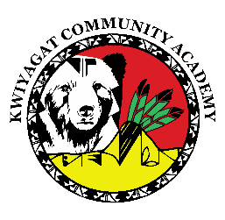
KCA Board Agenda April 9th, 2026
5 pm by Zoom and in person at KCA.
Dan Porter is inviting you to a scheduled Zoom meeting.

https://us02web.zoom.us/j/87959708862?pwd=pCRPR6tOp9pIwI7AeJ4FYvtZh1bAya.1
Meeting ID: 879 5970 8862
Passcode: 730777

Call to order
Welcome -
Roll Call
Approval of Agenda-Vote
Approval of the minutes for March 12th, 2026 meeting- Vote
Community addresses the Board:
Reports:
- Council Report – Councilwoman Knight
- Finance Committee Report
- Principal report

Discussion:
Expansion to 6th grade
1st look at lunch policy
Action Items
Policy on disclosure of information to Federal Immigration Authorities
2026-2027 School Calendar
Adjourn

